Q21. Insertion Sort with duplicate elements
Aim: To develop a Python program to insertion sort with duplicate elements and obtain the required output.
Algorithm:
1. Read the array elements.
2. Select the next element or pair of elements to process.
3. Compare values and rearrange them according to the required order.
4. Repeat until the array is ordered, then display the result.
Input:
3 1 4 1 5 9 2 6 5 3
Output:
Sorted: [1, 1, 2, 3, 3, 4, 5, 5, 6, 9]
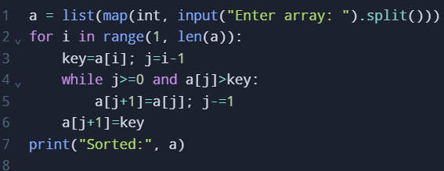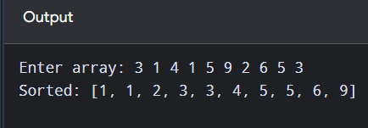
Time Complexity: O(n²)
Space Complexity: O(1)
Result: Therefore, the sorting procedure was carried out and the elements were displayed in the required order.

Q22. Kth positive missing number
Aim: To develop a Python program to kth positive missing number and obtain the required output.
Algorithm:
1. Read the required input values.
2. Use binary search or the required logarithmic search rule to reduce the search range.
3. Store/update the required intermediate values.
4. Display the final answer.
Input:
2 3 4 7 11
5
Output:
Kth missing: 9
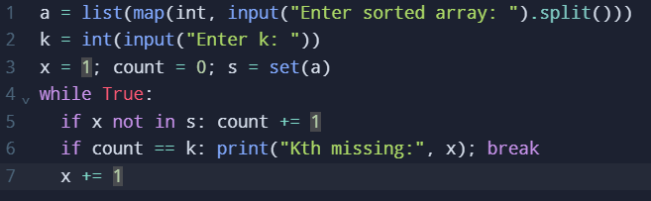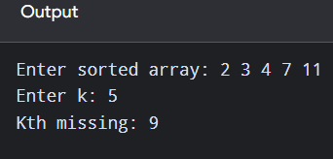
Time Complexity: O(n)
Space Complexity: O(n)
Result: Therefore, the search procedure was executed and the required element or position was obtained.

Q23. Peak element using O(log n)
Aim: To develop a Python program to peak element using o(log n) and obtain the required output.
Algorithm:
1. Read the sorted input and the target or required position.
2. Set the initial search boundaries.
3. Inspect the middle element and discard the half that cannot contain the answer.
4. Continue until the target is found or the required position is determined; display the answer.
Input:
1 2 3 1
Output:
Peak index: 2
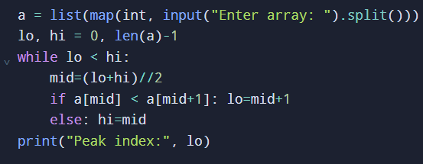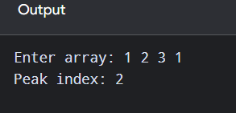
Time Complexity: O(log n)
Space Complexity: O(1)
Result: Therefore, the search procedure was executed and the required element or position was obtained.

Q24. First occurrence of a substring
Aim: To develop a Python program to first occurrence of a substring and obtain the required output.
Algorithm:
1. Read the string or list of strings.
2. Examine characters or words in the given order.
3. Apply the required string condition and record matching items.
4. Stop or continue as required, then print the resulting string or value.
Input:
sadbutsad
sad
Output:
Index: 0
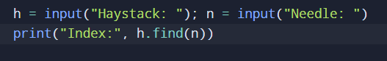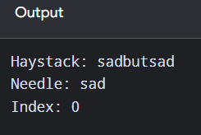
Time Complexity: O(nm)
Space Complexity: O(1)
Result: Therefore, the string-processing condition was checked and the required output was produced.

Q25. Strings that are substrings of another word
Aim: To develop a Python program to strings that are substrings of another word and obtain the required output.
Algorithm:
1. Read the string or list of strings.
2. Examine characters or words in the given order.
3. Apply the required string condition and record matching items.
4. Stop or continue as required, then print the resulting string or value.
Input:
mass as hero superhero
Output:
['as', 'hero']
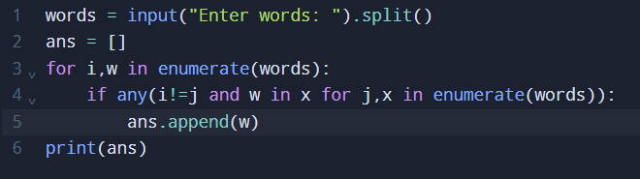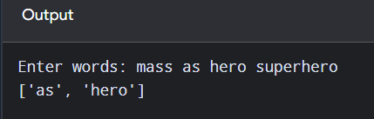
Time Complexity: O(n²L)
Space Complexity: O(n)
Result: Therefore, the string-processing condition was checked and the required output was produced.

Q26. Closest pair of points – brute force
Aim: To develop a Python program to closest pair of points – brute force and obtain the required output.
Algorithm:
1. Read the input array and any additional parameters.
2. Initialize counters, sets, or variables needed for the calculation.
3. Traverse the relevant elements and apply the condition stated in the problem.
4. Print the final count, sum, selected elements, or other required value.
Input:
4
1 2
4 5
7 8
3 1
Output:
Closest pair and distance
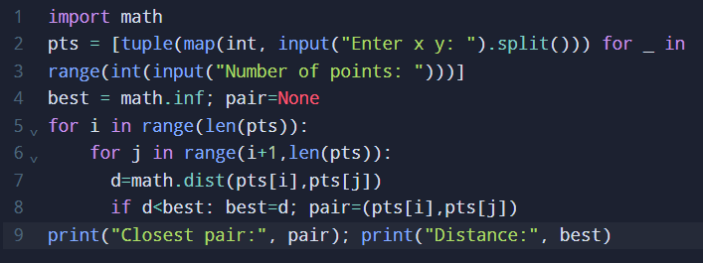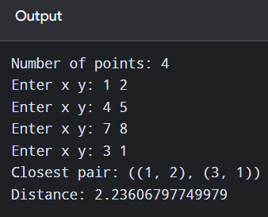
Time Complexity: O(n²)
Space Complexity: O(1)
Result: Therefore, the array was processed according to the given condition and the required result was displayed.

Q27. Convex Hull – brute force
Aim: To develop a Python program to convex hull – brute force and obtain the required output.
Algorithm:
1. Read the input data required by the problem.
2. Initialize variables or data structures needed for processing.
3. Process the input using the rule specified in the problem statement.
4. Display the computed result.
Input:
5
1 1
4 6
8 1
0 0
3 3
Output:
Convex hull
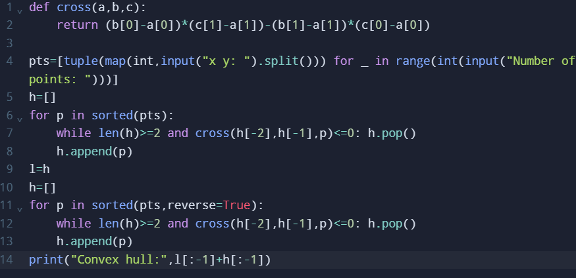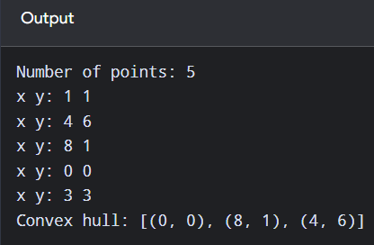
Time Complexity: O(n²)
Space Complexity: O(n)
Result: Therefore, the problem was processed using the stated steps and the output was obtained successfully.

Q28. Traveling Salesperson Problem – exhaustive search
Aim: To develop a Python program to traveling salesperson problem – exhaustive search and obtain the required output.
Algorithm:
1. Read the sorted input and the target or required position.
2. Set the initial search boundaries.
3. Inspect the middle element and discard the half that cannot contain the answer.
4. Continue until the target is found or the required position is determined; display the answer.
Input:
4
1 2
4 5
7 1
3 6
Output:
Minimum distance and path
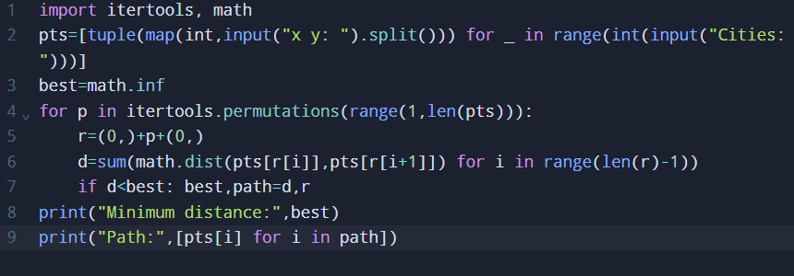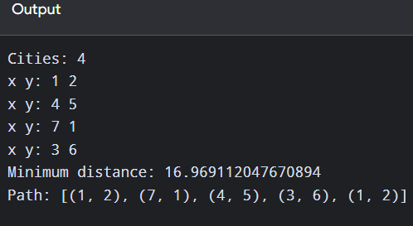
Time Complexity: O(n!)
Space Complexity: O(n)
Result: Therefore, the search procedure was executed and the required element or position was obtained.

Q29. Assignment Problem – exhaustive search
Aim: To develop a Python program to assignment problem – exhaustive search and obtain the required output.
Algorithm:
1. Read the sorted input and the target or required position.
2. Set the initial search boundaries.
3. Inspect the middle element and discard the half that cannot contain the answer.
4. Continue until the target is found or the required position is determined; display the answer.
Input:
3
3 10 7
8 5 12
4 6 9
Output:
Assignment and minimum cost: 19
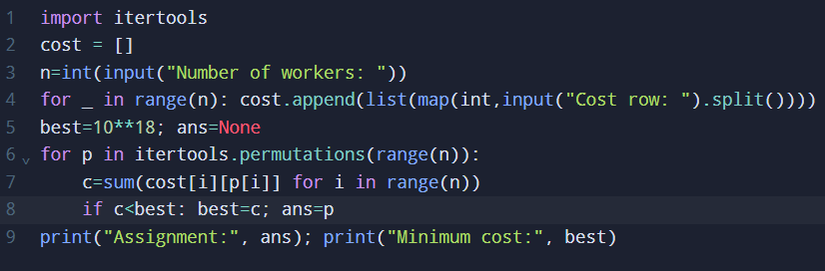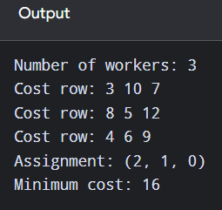
Time Complexity: O(n!)
Space Complexity: O(n)
Result: Therefore, the search procedure was executed and the required element or position was obtained.

Q30. 0-1 Knapsack – exhaustive search
Aim: To develop a Python program to 0-1 knapsack – exhaustive search and obtain the required output.
Algorithm:
1. Read the sorted input and the target or required position.
2. Set the initial search boundaries.
3. Inspect the middle element and discard the half that cannot contain the answer.
4. Continue until the target is found or the required position is determined; display the answer.
Input:
2 3 1
4 5 3
4
Output:
Selected: [0, 2], Value: 7
Time Complexity: O(2^n)
Space Complexity: O(n)
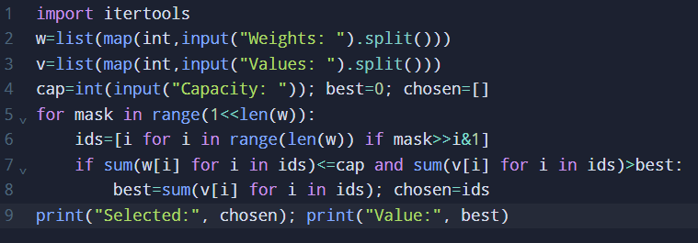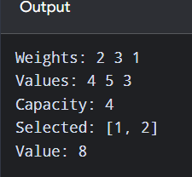
Result: Therefore, the search procedure was executed and the required element or position was obtained.

